ARPAN SHIRSHETTY

2097

PRAC 10

AJP

HTML FOR HELLO WORLD

INPUT:

<%@ **page** language=*"java"* contentType=*"text/html; charset=ISO-8859-1"*

pageEncoding=*"ISO-8859-1"*%>

<!**DOCTYPE** html>

<**html**>

<**head**>

<**meta** charset=*"ISO-8859-1"*>

<**title**>Insert title here</**title**>

</**head**>

<**body**>

<**h1**>"HELLO World!</**h1**>

</**body**>

</**html**>

OUTPUT:

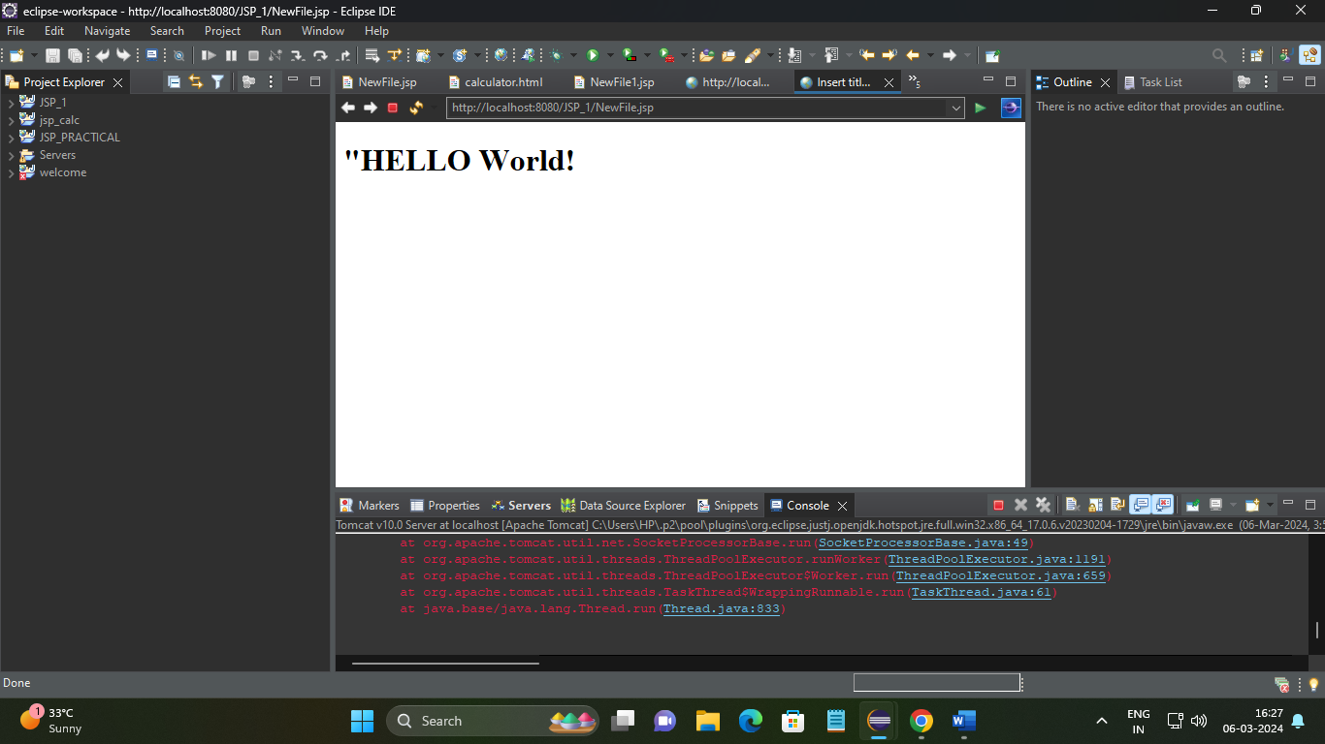

CALCULATOR

STEP 1:HTML CODE

<!**DOCTYPE** html>

<**html**>

<**title**>Sample Example </**title**>

<**body**>

<**h1**> Example of JSP </**h1**>

<**b**> Mathematics</**b**>

<**hr**>

<**form** method=*"post"* action=*"NewFile1.jsp"*>

<**font** size=*5* face=*"Times New Roman"*>

<**input** type=*"radio"* name=*"a1"* value=*"add"* checked>Addition<**br**>

<**input** type=*"radio"* name=*"a1"* value=*"sub"* >Subtraction<**br**>

<**input** type=*"radio"* name=*"a1"* value=*"mul"* >Multiplication<**br**>

<**input** type=*"radio"* name=*"a1"* value=*"div"* >Division <**br**>

</**font**>

<**br**><**br**>

Enter first Value <**input** type=*"text"* name=*"t1"* value=*""*><**br**>

Enter second Value <**input** type=*"text"* name=*"t2"* value=*""*><**br**>

<**input** type=*"submit"* name=*"result"*>

</**form**>

</**body**>

</**html**>

JSP FILE CODE:

<%@ **page** language=*"java"* contentType=*"text/html; charset=ISO-8859-1"*

pageEncoding=*"ISO-8859-1"*%>

<%@ **page** language=*"java"*%>

<%@ **page** import=*"java.lang.*"*%>

<**html**>

<**body**>

<**h1**> Result for <%=request.getParameter("a1")%></**h1**>

<%

int i=Integer.parseInt(request.getParameter("t1"));

int j=Integer.parseInt(request.getParameter("t2"));

int k=0;

String str=request.getParameter("a1");

if(str.equals("add"))

k=i+j;

if(str.equals("sub"))

k=i-j;

if(str.equals("mul"))

k=i*j;

if(str.equals("div"))

k=i/j;

%>

Result is <%=k%>

</**body**>

</**html**>

OUTPUT:

